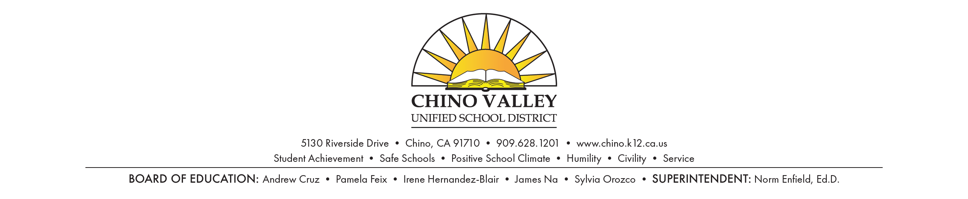

**PRESS RELEASE**

**FOR IMMEDIATE RELEASE** **CONTACT:** Imee Perius

November 5, 2018 (909) 628-1201 ext. 1616

**Chino Valley Unified School District announces call for nominees for Richard Gird Educational Hall of Fame**

CHINO, Calif. – The nomination period for the Chino Valley Unified School District (CVUSD) Richard Gird Educational Hall of Fame is now open through January 31, 2019. Nomination applications can be found on the Chino Valley Unified School District website at <https://bit.ly/2DoJOEM> and also attached as separate files to this release.

The CVUSD Richard Gird Educational Hall of Fame annually recognizes distinguished CVUSD graduates, employees, and major contributors for their individual contributions in scholarship, athletics, Associated Student Body (ASB) activities, career, community service, and/or society as a whole to the CVUSD community. Individuals elected to the CVUSD Richard Gird Educational Hall of Fame are those who have contributed to the vision of the School District.

Nominees may be submitted in three different categories with the following eligibility criteria:

***Alumni Inductee:*** Student athletes, scholars or ASB activity participants become eligible for nomination ten (10) years after graduating from any CVUSD school. Alumni must have earned individual recognition at a District school by their scholastic achievement, athletic accomplishments, ASB activities or community service; Alumni must have earned individual recognition after graduation by their postsecondary scholastic achievement, athletic accomplishments, career/professional accomplishments, military service, or community service; and Alumni must have led an exemplary life of community service and good character must have followed the student after graduation.

***Distinguished Service Inductee:*** The nominee must have made extraordinary contributions to CVUSD resulting in significant benefit or exceptional honor to the District or one of its schools.

***Employee Inductee:*** A former employee becomes eligible for nomination five (5) years after retiring or departing from CVUSD. Eligible candidates must have evidence of an outstanding career within the CVUSD. The nominee must have had a direct and significant impact on scholastics, athletics, or other student-centered activities. He/she must have had an exemplary life of community service and good character reflecting credit to the person, the school, and society.

Richard Gird Hall of Fame inductees are elected by a committee comprised of community leaders and members appointed by the CVUSD Board of Education. Inductees will be notified in the first quarter of 2019 and honored at the annual Employee Awards and Hall of Fame Recognition Ceremony in May 2019.

###